Admin Login Page-

Here only Admins can make login to avail the features and functionalities like assigning users roles and login ID and other features also.

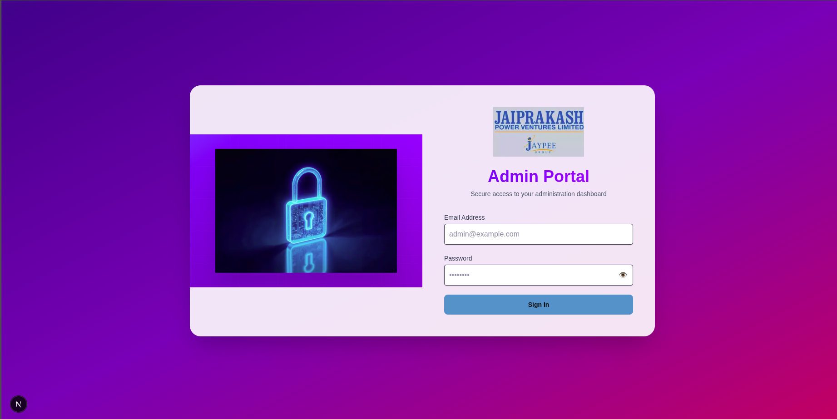  
  
Admin Dashboard Page-

This is the Admin Dashboard Page, after making successful login from the above login page, admins get redirected to this page.

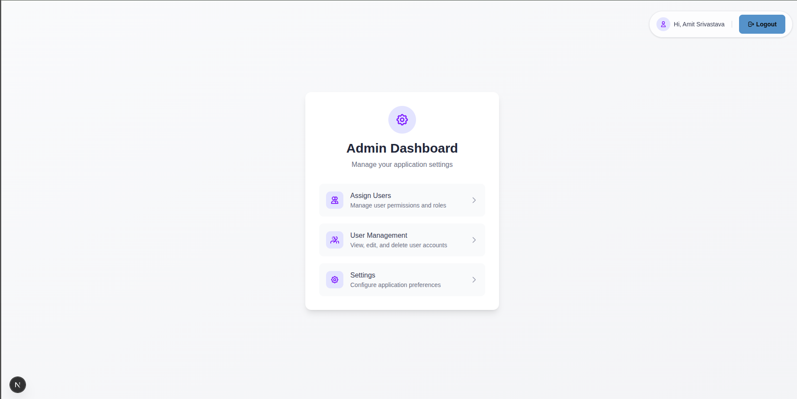

New User Creation Page -

Admin can select “Assign Users” option from the above page, and get redirected to this page, where they can assign user with their respective roles, status. And this email ID can be used by the user to make their login and update their password.

For Ex. In below image, admin has made a user with name Moni Tiwari, [moni@gmail.com](mailto:moni@gmail.com), Role- Shift Engineer, and the status is Pending (this will automatically gets changed to Active, when the user makes their first login) and the default password for now in database is saved as [cdc@123](mailto:cdc@123).

Now, this user will go to the main login page (attached below), to update her password.

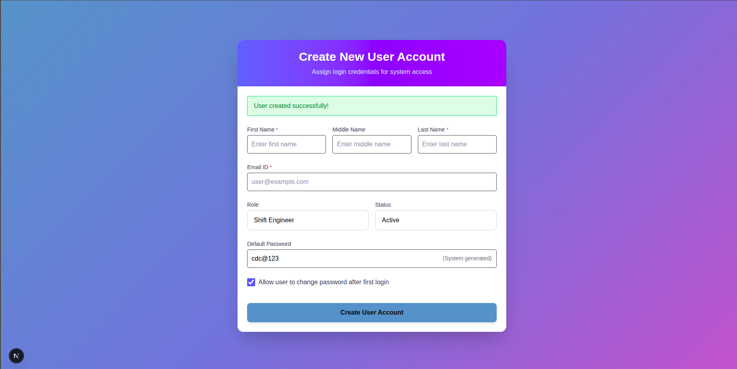

Password Updation Page -

This is the page, where user will come to update his/her password after he/she will get the Login mail I’d and Role assigned from the admin to login. They will enter their email address, Role, New Password and Confirm password. Then as they will click Set New Password, new password will be set as Default and Confirm Password. The Password will be hashed because of privacy issues, using JWT Token.

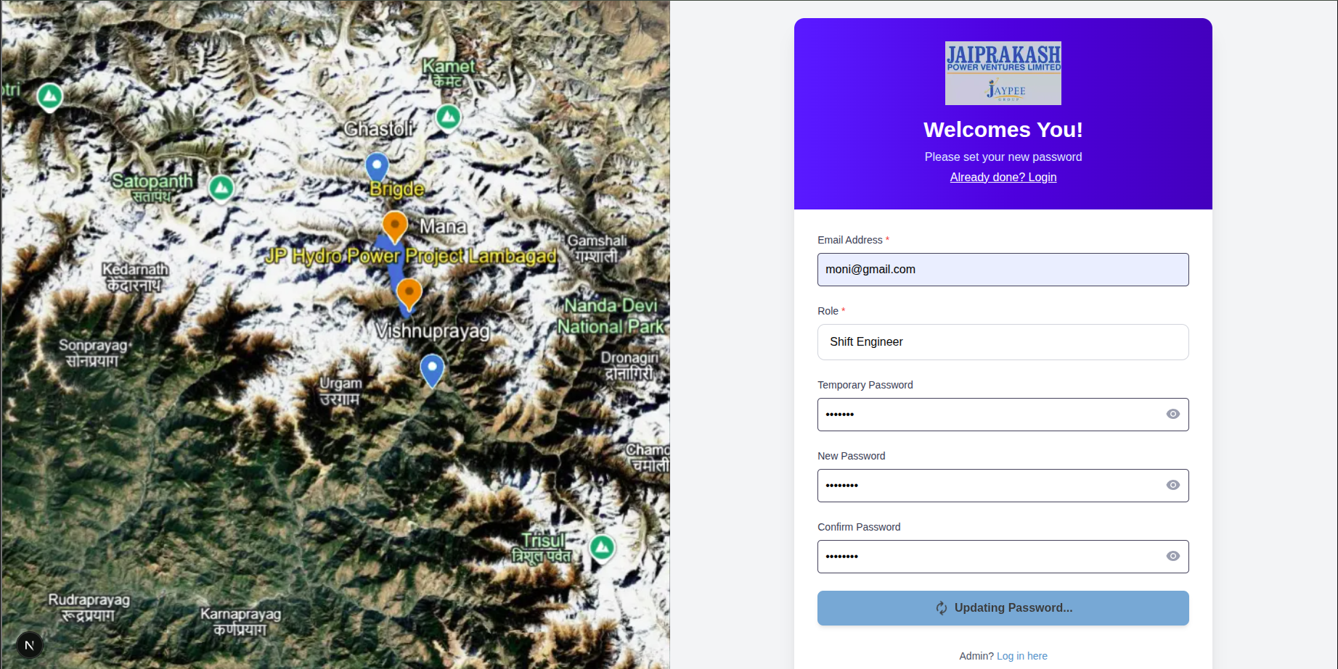

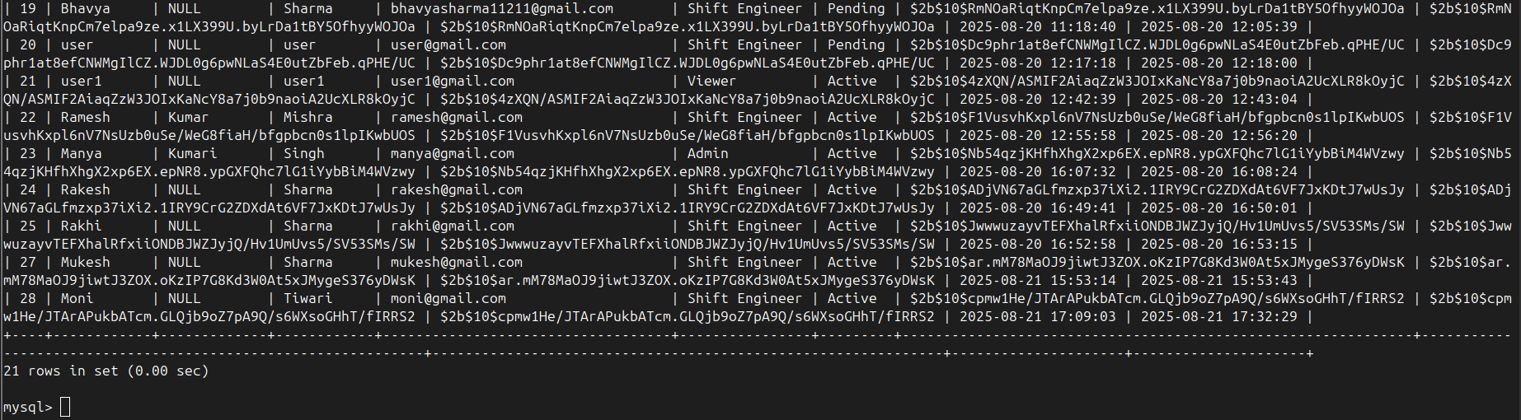

Login Page -

Then right after password updation, the user will get redirected to the Login Page to make login using their credentials.

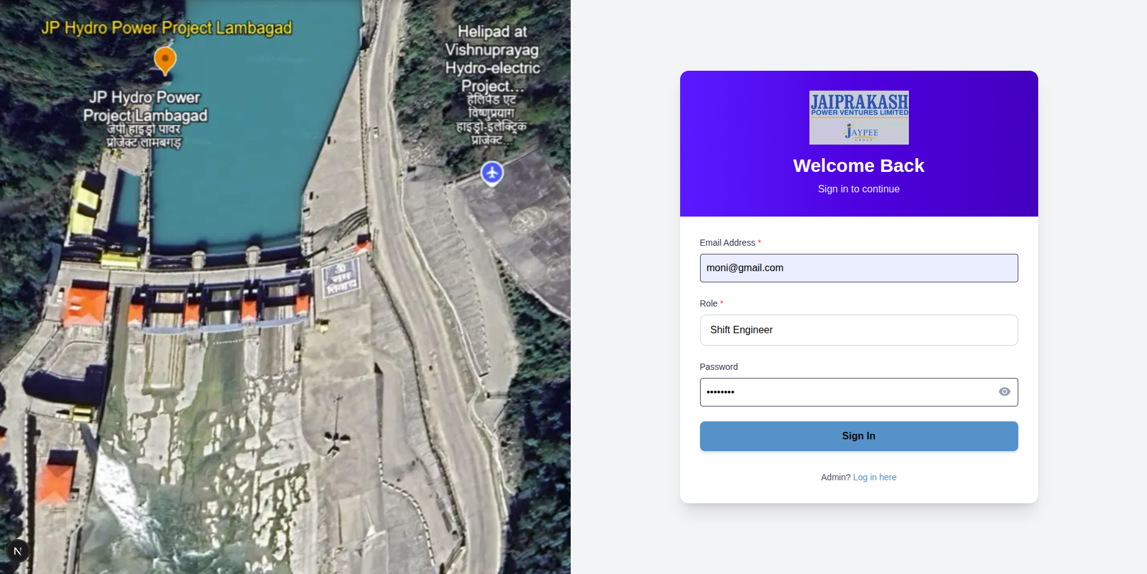  
  
Dashboard Page -

Then after successful login, the user will get redirected to the dashboard page.

